Additional Information and Resources
One of the most overlooked expenses in AWS is data storage. You have been tasked with architecting a design to cost-effectively store your data, based off the data's usage patterns. You have decided to use S3 as your data storage and create S3 lifecycle policies to more your data to the appropriate storage class. Let's get started!
Use the provided credentials to log in to the AWS Management Console. Make sure you are in the us-east-1 region throughout the lab. Here's where to download the image you'll need when we upload an object.
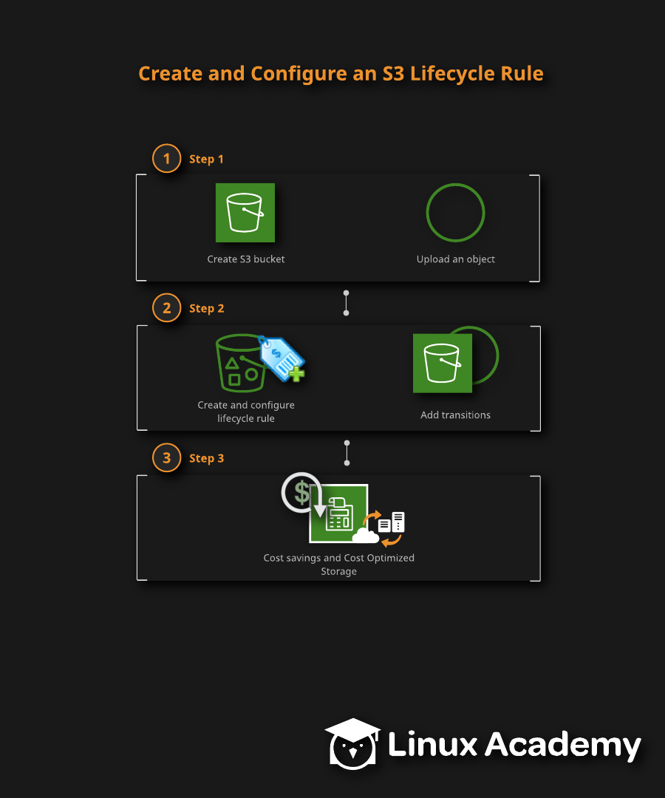

Creating and Configuring an S3 Lifecycle Policy

Introduction
A great way to reduce your expenses in AWS and achieve cost optimization is by optimizing your storage. You can create lifecycle rules to help transition your data to meet the actual usage needs of accessing that data, which will not only optimize your storage but also save you money. In this lab, we will create an S3 bucket, upload an object, and then create and configure an S3 lifecycle rule.

Solution

Log into the AWS Management COnsole
- Before we start the lab, use the provided credentials to log in to the AWS Management Console.
- Make sure that we are in the us-east-1 region, which will appear as N.Virginia at the top of the screen next to the Support dropdown.
- Use this link to download the image that we will be using for this lab: Our GitHub image for download.

Create an S3 Bucket
- On the AWS Management Console, select the Services dropdown.
- In the Storage section, select S3.
- On the S3 buckets page, select the orange Create bucket button.
- In Bucket name, provide a unique name of whatever you choose. Remember that we must use all lowercase letters and no special characters.
- For Region, leave it as the US East (N. Virginia) us-east-1.
- Scroll down to the bottom and select Create bucket.
- Click on our newly created bucket.
- Click the orange Upload button.
- Click the Add files button.
- Select a file to upload.
- Scroll to the bottom and click the orange Upload button to upload your file.
- Once the file is successfully uploaded, click the Exit button.

Create and Configure a New S3 Lifecycle Policy
- Click on the Management tab in the bucket.
- Under Lifecycle rules, click the Create lifecycle rule button.
- Configure a lifecycle rule for the files in our bucket:
  - Under Lifecycle rule name, provide the name "S3stdtoglacier".
  - Under Choose a rule scope, click the radio button next to This rule applies to all objects in our bucket.
  - Under Lifecycle rule actions, click the radio button next to Transition current versions of objects between storage classes to set up a transition of objects from Standard to Glacier.
  - In the Storage class transition dropdown menu, select Standard-IA.
  - Under Days after creation, enter "30."
  - Add a second transition by clicking the Add transition button.
  - In the Storage class transition dropdown menu, select Glacier.
  - Under Days after creation, enter "90."
  - Check the box to acknowledge that this lifecycle rule will increase the one-time lifecycle request cost if it transitions small objects.
  - Under Lifecycle rule actions, click the radio button next to Transition previous versions of objects between storage classes to set up a transition of previous versions of objects.
- Scroll down to the bottom and click the Create rule button.
- On our bucket's page, view the bucket's rule and verify that it is correct.

Conclusion
Upon completing this lab, we are now able to create S3 buckets, upload files to said buckets, and then create rules about what to do with these files. Congratulations on finishing this lab!

